The Paradigm as a Radial Category
Tore Nesset and Laura A. Janda, University of Tromsø
CLEAR group: Cognitive Linguistics – Empirical Approaches to Russian

- Suffix shift: Ongoing language change whereby Russian verbs replace the non-productive suffix–a by the productive –aj. The verb kapat’ ‘drip’ has both -a suffixed forms like kapljut and innovative -aj suffixed forms like kapajut.

- Slezy kapljut odna za drugoj na klaviši. (Gončarov 1859, with -a suffix)
‘The tears drip one after another onto the keyboard.’
- Slezy v šči kapajut. (Bitov 1969, with -aj suffix)
‘The tears drip into the cabbage soup.’
- Forms of kapat’ ‘drip’ with original -a suffix and innovative -aj suffix
 | -a suffix | -aj suffix
Non-Past 1sg | kaplju | kapaju
Non-Past 2sg | kapleš’ | kapaeš’
Non-Past 3sg | kaplet | kapaet
Non-Past 1pl | kaplem | kapaem
Non-Past 2pl | kaplete | kapaete
Non-Past 3pl | kapljut | kapajut
Present Active Participle | kapljuščij | kapajuščij
Imperative | kapli(te) | kapaj(te)
Gerund | kaplja | kapaja
Infinitive | kapat’ | kapat’
Past masc sg | kapal | kapal
Past fem sg | kapala | kapala
Past neut sg | kapalo | kapalo
Past pl | kapali | kapali
- Suffix shift is well documented in the literature, cf. e.g. Andersen 1980, Gagarina 2003, Gor & Chernigovskaya 2001, 2003a-b and 2005, Graudina et al. 2001, Kiebzak-Mandera 1997, Švedova (red.) 1980, Tkachenko & Chernigovskaya 2006, Zaliznjak 1977. Our starting point is a database comprising about 20,000 examples from The Russian National Corpus.
- Verbs undergoing suffix shift (to different degrees):
Verb | #a | #aj | #Total | %aj
alkat’ ‘hunger’ | 123 | 10 | 133 | 8
blistat’ ‘shine’ | 249 | 272 | 521 | 52
bryzgat’ ‘spatter’ | 222 | 119 | 341 | 35
vnimat’ ‘perceive’ | 95 | 273 | 368 | 74
glodat’ ‘gnaw’ | 158 | 6 | 164 | 4
dremat’ ‘slumber’ | 492 | 1 | 493 | 0.2
dvigat’ ‘move’ | 1093 | 479 | 1572 | 30
žaždat’ ‘thirst’ | 1239 | 16 | 1255 | 1
kapat’ ‘drip’ | 78 | 106 | 184 | 58
klepat’ ‘slander’ | 15 | 15 | 30 | 50
klikat’ ‘call’ | 184 | 11 | 195 | 6
kloxtat’ ‘cluck’ | 10 | 1 | 11 | 9
kolebat’ ‘rock’ | 134 | 1 | 135 | 0.7
kolyxat’ ‘sway’ | 79 | 9 | 88 | 10
krapat’ ‘sprinkle’ | 1 | 2 | 3 | 67
kudaxtat’ ‘cackle’ | 22 | 19 | 41 | 46
kurlykat’ ‘call (crane)’ | 15 | 5 | 20 | 25
maxat’ ‘wave’ | 930 | 302 | 1232 | 25
metat’ ‘cast’ | 185 | 7 | 192 | 4
murlykat’ ‘purr’ | 91 | 61 | 152 | 40
mykat’ ‘moo’ | 1 | 11 | 12 | 92
paxat’ ‘plough’ | 353 | 2 | 355 | 0.6
pleskat’ ‘splash’ | 165 | 18 | 183 | 10
poloskat’ ‘rinse’ | 80 | 5 | 85 | 6
prjatat’ ‘hide’ | 1341 | 2 | 1343 | 0.1
pryskat’ ‘spray’ | 11 | 35 | 46 | 76
pyxat’ ‘blaze’ | 201 | 9 | 210 | 4
ryskat’ ‘trot’ | 114 | 99 | 213 | 46
stonat’ ‘moan’ | 698 | 17 | 715 | 2
svistat’ ‘whistle’ | 7 | 1 | 8 | 13
tykat’ ‘poke’ | 439 | 119 | 558 | 21
xlestat’ ‘whip’ | 313 | 1 | 314 | 0.3
xnykat’ ‘whine’ | 96 | 33 | 129 | 26
čerpat’ ‘draw’ | 4 | 304 | 308 | 99
ščekotat’ ‘tickle’ | 267 | 1 | 268 | 0.4
ščepat’ ‘chip’ | 0 | 2 | 2 | 100
ščipat’ ‘pinch’ | 150 | 8 | 158 | 5
Total | 9655 | 2382 | 12037
- Two alternative approaches to paradigms
- Aristotelian category: A paradigm is a list of the inflected forms of a lexeme. The list lacks internal structure– all forms have the same status. Ex: The Word and Paradigm model (Matthews 1972), Optimal paradigms (Mc Carthy 2005)
- Radial category (Lakoff 1987): Paradigms have internal structure insofar as asymmetrical relationships hold between prototypical and peripheral forms (cf. Bybee 1985, Wurzel 1984 & 1989)
- Language change: Empirical predictions
- Aristotelian category: If we assume that paradigms lack internal structure, we expect all forms to be equally affected by language change.
- Radial category: If we assume that paradigms have internal structure, we expect different forms to be affected by language change to different degree. Peripheral forms are expected to be most innovative.
- Method: Statistical analysis by means of Logistic Mixed Effects Modeling, a method that facilitates analysis of the impact of a number of relevant factors.
- Hierarchy: Forms ranked according to prototypicality
3 sg > 3 pl > 1 & 2 person > imperative > participle/gerund
- Predictions:
- 3 sg is the most conservative form (least affected by suffix shift)
- Participle and gerund are the most innovative forms (most affected by suffix shift)

- Results
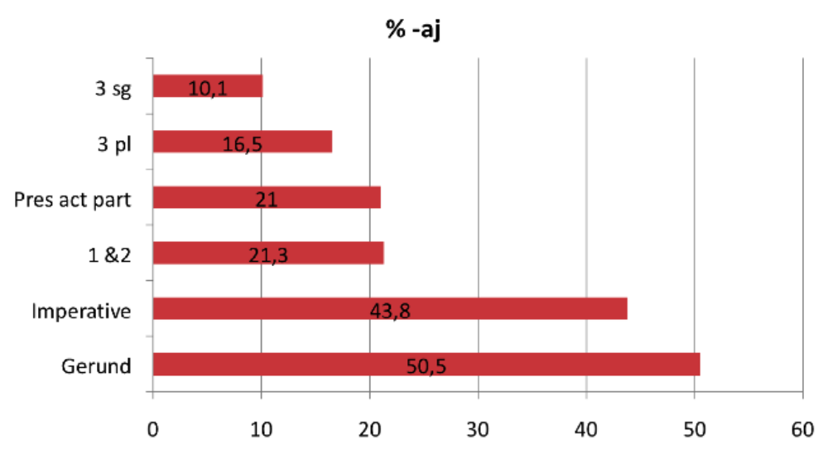

- Interpretation of results:
- Results suggest that the predictions are correct.
- However, the participle is a problem, insofar as it behaves like a finite form with regard to suffix shift.
- Hypothesis about the active participle:
Relationships of form override prototypicality. The fact that the participle behaves like a finite form is motivated by its formal resemblance of finite forms (the 3 pl). Participles represent a so-called parasitic formation from the 3 pl in the sense that the participle “borrows” the vowel from the 3 pl ending (cf. čitajut – čitajuščij, govorjat – govorjaščij)
- Frequency – an alternative hypothesis about suffix shift:
The least frequent forms are most prone to undergo suffix shift.
- Frequency yields incorrect predictions for the gerund
- Prototypicality: 3 sg > 3 pl > 1 & 2 pers > imp > gerund
- Frequency: 3 sg > 3 pl > gerund > 1 & 2 pers > imp
- Frequency – written vs. spoken language:
Maybe the high frequency of the gerunds is due to the fact that spoken language is underrepresented in the corpus (and hence in our database)? If gerunds are less frequent in spoken Russian, maybe the frequency hypothesis can be saved?
- Gerund frequencies in written and spoken Russian:
 | # lemmas | # gerunds | % gerunds
Whole corpus | 13581979 | 501036 | 3.7
Spoken corpus | 135326 | 1522 | 1.1
The difference between written and spoken language is statistically significant (p<2.2e-16), but the effect size is less than “small” (Cramer’s V = 0.01). This suggests that the frequency difference has minimal impact. It is nevertheless impossible to exclude that frequency is relevant for suffix shift.
- Summing up
- Suffix shift is sensitive to morphosyntactic features insofar as different forms are affected to different degrees: 3 sg is the most conservative form, while the gerund is most innovative.
- Paradigm structure: Our results are compatible with the hypothesis that paradigms are radial categories with internal structure.
- Frequency: It is possible, but not very likely that frequency is of decisive importance.

Bibliography
Andersen, Henning. 1973. Abductive and deductive change. Language 49. 765-793.
Andersen, Henning. 1980. Russian conjugation: Acquisition and evolutive change. In Elizabeth C. Traugott et al. (eds.), Papers from the 4th international conference on historical linguistics, 285-301. Amsterdam: John Benjamins.
Andersen, Henning. 1989. Markedness theory -- the first 150 years. In Olga M. Tomic (ed.), Markedness in synchrony and diachrony, 11-47. Berlin: Mouton de Gruyter.
Andersen, Henning. 2001. Markedness and the theory of linguistic change. In Henning Andersen (ed.), Actualization: Linguistic Change in Progress, 21-58. Amsterdam and Philadelphia: John Benjamins.
Bybee, Joan. 1985. Morphology. Amsterdam/Philadelphia: John Benjamins.
Gagarina, Natalija. 2003. The early verb development and demarcation of stages in three Russian-speaking children. In Dagmar Bittner, Wolfgang U. Dressler & Marianne Kilani-Schoch (eds.), Development of verb inflection in first language acquisition: A cross-linguistic perspective, 131-170. Mouton de Gruyter: Berlin - New York.
Gor, Kira & Tatiana Chernigovskaya. 2001. Rules in the processing of Russian verbal morphology. In Gerhild Zybatow, Uwe Junghanns, Grit Melhorn & Luka Szucsich (eds.), Current issues in formal Slavic linguistics, 528-536. Frankfurt am Main: Peter Lang.
Gor, Kira & Tatiana Chernigovskaya. 2003a. Mental lexicon structure in L1 and L2 acquisition: Russian evidence. GLOSSOS 4. 1-31.
Gor, Kira & Tatiana Chernigovskaya. 2003b. Generation of complex verbal morphology in first and second language acquisition: Evidence from Russian. Nordlyd 31(6). 819-833.
Gor, Kira & Tatiana Chernigovskaya. 2005. Formal instruction and the acquisition of verbal morphology. In Alex Housen & Michel Pierrard (eds.), Current issues in instructed second language learning, 103-136. Berlin and New York: Mouton de Gruyter.
Graudina, Ludmila K., Viktor A. Ickovič & Lija P. Katlinskaja. 2001. Grammatičeskaja pravil’nost’ russkoj reči. Stilističeskij slovar’ variantov. [Grammatical correctness in spoken Russian: Stylistic dictionary of variants.] Moscow: Nauka.
Halle, Morris and Alec Marantz. 1993. Distributed morphology and the pieces of inflection. In Kenneth Hale and Samuel J. Keyser (eds.), The view from building 20, 111-176. Cambridge, MA: MIT Press.
Hockett, Charles F. 1958. Two models of grammatical description. In Martin Joos (ed.), Readings in Linguistics, 386-399. Chicago: University of Chicago Press.
Janda, Laura A. 1995. Unpacking markedness. In Eugene Casad (ed.), Linguistics in the redwoods: The expansion of a new paradigmin linguistics, 207-233. Berlin: Mouton de Gruyter.
Janda, Laura A., Tore Nesset & R. Harald Baayen. (2010). Capturing correlational structure in Russian paradigms: A case study in logistic mixed-effects modeling. Cognitive Linguistics and Linguistic Theory 6(1). 29-48.
Joseph, Brian. 1983. The synchrony and diachrony of the Balkan infinitive. Cambridge: Cambridge University Press.
Karlsson, Fred. 1985. Paradigms and word forms. Studia gramatyczne VII. Ossolineum. 135-154.
Karlsson, Fred. 1986. Frequency considerations in morphology. Zeitschrift für Phonetik, Sprachwissenschaft und Kommunikationsforschung 39. 19-28.
Kiebzak-Mandera, Dorota, Magdalena Smoczynska & Ekaterina Protassova. 1997. Acquisition of Russian verb morphology: the early stages. In Wolfgang U. Dressler (ed.), Studies in pre- and protomorphology, 101-114. Wien: Verlag der österreichischen Akademie der Wissenschaften.
Krysin, Leonid P. (ed.). 1974. Russkij jazyk po dannym massovogo obsledovanija [The Russian language according to data from empirical investigation]. Moscow: Nauka.
Lakoff, George. 1987. Women, Fire, and Dangerous Things. Chicago: University of Chicago Press.
Mańczak, Witold. 1980. Laws of analogy. In Jacek Fisiak (ed.), Historical morphology, 283-288. The Hague, Paris and New York: Mouton Publishers.
Matthews, Peter H. 1972. Inflectional morphology. A theoretical study based on aspects of Latin verb conjugation. Cambridge: Cambridge University Press.
Matthews, Peter H. 1991. Morphology. 2nd ed. Cambridge: Cambridge University Press.
McCreight, Katherine & Catherine V. Chvany. 1991. Geometric representation of paradigms in a modular theory of grammar. In Frans Plank (ed.), Paradigms. The economy of inflection, 91-111. Berlin and New York: Mouton de Gruyter.
McCarthy, John J. 2005. Optimal paradigms. In Laura J. Downing, T. Alan Hall & Renate Raffelsiefen (eds.), Paradigms in phonological theory, 170-210. Oxford: Oxford University Press.
Nesset, Tore. 1998. Russian conjugation revisited: A cognitive approach to aspects of Russian verb inflection. Oslo: Novus Press.
Nesset, Tore. 2008. Ob''jasnenie togo, čto ne imelo mesto: Blokirovka suffiksal'nogo sdviga v russkix glagolax. Voprosy jazykoznanija 6. 35-48.
Nesset, Tore. 2010. Suffix shift in Russian verbs: a case for markedness? Russian Linguistics 34.2. 123-138.
Nesset, Tore and Laura A. Janda. 2010. Paradigm structure: Evidence from Russian suffix shift. Cognitive Linguistics 21-4. 691-717.
Plank, Frans. 1990a. Of abundance and scantiness in inflection: a typological prelude. In Frans Plank (ed.), Paradigms. The economy of inflection, 1-39. Berlin and New York: Mouton de Gruyter.
Švedova, Natalija Ju. (ed.). 1980. Russkaja grammatika [Russian grammar] (vol. 1). Moscow: Nauka.
Tkachenko, Elena & Tatiana Chernigovskaya. 2006. Focus on form in the acquisition of inflectional morphology by L2 learners: Evidence from Norwegian and Russian. Paper presented at The Second Biennial Conference on Cogntive Science, St. Petersburg, June 9-13 2006.
Wurzel, Wolfgang U. 1984. Flexionsmorphologie und Natürlichkeit. Berlin: Akademie-Verlag.
Wurzel, Wolfgang U. 1989. Inflectional morphology and naturalness. Dordrecht, Boston and London: Kluwer Academic Publishers.
Zaliznjak, Andrej A. 1977. Grammatičeskij slovar’ russkogo jazyka [Grammatical dictionary of Russian]. Moscow: Izdatel’stvo Russkij Jazyk.

Examples (2) and (3) are from the Russian National Corpus: www.ruscorpora.ru.
The table includes only simplex verbs (unprefixed verbs without reflexive postfix –sja).
We would like to thank R. Harald Baayen for help with the statistical analysis.

